DealHunter : Price Comparison Application

Nitin M Shivale

Dept. of CS. BSIOTR, Pune, India

shivalenitin23@gmail.com

Gaurav Dhokchaule

Dept. of CS. BSIOTR, Pune, India

[ergauravdhokchaule@gmail.com](mailto:ergauravdhokchaule@gmail.com)

Vaishnavi Khot

Dept. of CS. BSIOTR, Pune, India

[khotvaishnavi809@gmail.com](mailto:khotvaishnavi809@gmail.com)

Mansi Badwar

Dept. of CS. BSIOTR, Pune, India

[mansi.badwar@gmail.com](mailto:mansi.badwar@gmail.com)

Prerna Kapse

Dept. of CS. BSIOTR, Pune, India

[prernakapse001@gmail.com](mailto:prernakapse001@gmail.com)

**Abstract:** Imagine we are shopping online, and we want to make sure we are getting the best deal. That's where price comparison apps come in, and DealHunter is one of the most popular ones out there. In this review, we take a deep dive into how DealHunter works, what makes it special, and how easy it is to use. First, we explain how DealHunter finds and updates prices. It's like a detective searching for the best deals on products. We'll also explore how many products it knows about – the more, the better. Next, we look at how DealHunter shows us the information. Is it simple to use? Can we easily find what we are looking for? We'll check if it's user-friendly, like a friendly guide helping we find the best prices.But we don't stop there. We also compare DealHunter to other similar apps. What makes it stand out? Is it faster, more accurate, or more fun to use? We'll tell you. We've also listened to what people who use DealHunter have to say. They've shared their thoughts – what they like and what they wish could be better. It's like asking our friends for advice on where to shop. In the end, we'll give you the big picture. Does DealHunter make shopping easier? Is it a must-have for smart shoppers? We'll sum it up and suggest ways it could become even better. So, if we want to make sure we are not spending more than we should when we shop, this review will help us to decide if DealHunter is the right tool for us. To obtain Product Detail, Web Scraping is use to fetch data.

**Keywords:** DealHunter, Web Scraping, Price comparison, User-friendly interface, Shopping efficiency, User feedback.

# I.Introduction

Shopping in today's world can be overwhelming, with endless options and prices to consider. That's where the DealHunter Price Comparison App steps in. It's like having a shopping expert at our fingertips, helping us to find the best deals and save money. In this review, we'll take a closer look at this app to see if it lives up to its promises. First, we'll explore the app's features. From Latest Alert to searching for products, we'll see how it helps us to compare prices and gather information. Then, we'll talk about the user experience. Is it easy to use? Does it provide clear results? We'll also check how fast and accurate it is in finding great deals. To give us the whole picture, we'll compare it with other similar apps, and we'll share what real users think about it. So, whether we are a potential user looking for a smart shopping companion or someone curious about how this app fits in the market, our review will provide you with the answers. In a world where every penny counts, the DealHunter Price Comparison App aims to make shopping easier and more budget-friendly. Let's see if it delivers on its promises.

The technologies use by systems are:

1. **Web Scraping :** Web scraping functionality is implemented within the Node.js backend, which collects and processes data from websites.
2. **Flutter :** Flutter serves as the user interface layer, allowing users to interact with your application.
3. **ExpressJs :** Express.js acts as the middleware that handles data requests, communicates with the database, and serves data to the Flutter front-end.

**MongoDB :** Data is stored in MongoDB, offering a scalable and efficient storage solution for user Authentication.

**Figma :** Figma is used in the design phase for creating wireframes and visualizing the application's user interface.

This technology stack provides a comprehensive solution for developing a web scraping and crawling application with a user-friendly interface, efficient data processing, and robust storage capabilities.

**II. System Architecture**

The DealHunter Price Comparison App is like a trusty shopping companion that fits right in our pocket, making our shopping experience a whole lot smarter. Let's delve into its world and understand what makes it such a standout:

First and foremost, it was created to solve a problem many of us face, making the best choices when we shop. This app wanted to help people like we become savvy shoppers by providing a simple way to compare prices and gather important information about products. This app is their answer to that need. Now, this app isn't exclusive to one type of shopper. It's a tool for everyone, whether we are a tech- savvy young adult hunting for online bargains or someone who loves the traditional in-store experience but still wants to be sure w are getting the best deal around. It's designed to be a helpful shopping sidekick, no matter our preferences. Not to mention, it's available on Android and iOS devices, so it's super accessible. Whether we are an Apple aficionado or an Android enthusiast, this app is there for us. The real magic of the DealHunter Price Comparison App lies in its product database. It's like a digital treasure trove filled with all sorts of goodies, from the latest electronics and trendy clothing to everyday household items and more. So, whether we are on the hunt for a new gadget, a fabulous outfit, or just your regular groceries, we are likely to find what we need in this vast collection. And the best part? The app keeps everything up to date in real time. That means we will know when prices change and when special deals pop up. No more scouring the web for hours or hopping from one store to another to find the best deal. It's all at our fingertips, constantly refreshed.

Now, who doesn't like to know what other people think? This app offers a space for users to leave reviews and rate products. It's like having our friends recommend things to us. we can read what others have experienced and make more informed choices. Plus, there's a notification system. We can get alerts about price drops and special deals on products we like. No more fretting about missing out on discounts - this app keeps us in the loop. Another fantastic feature is price history. Imagine we want to buy something that's not urgent. This app can show you how the price has changed over time. It's like having a crystal ball that helps us decide the best time to make our purchase. But wait, there's more! The DealHunter Price Comparison App isn't just about comparing prices; it's got some other tricks up its sleeve too. We can create a shopping list so we don't forget what we need, find stores nearby using store locators, and even make a wishlist for those products we will get someday. In a world where every dollar counts, this app is on a mission to make shopping smarter and save our money. So, whether we are a tech whiz or just someone who loves a good deal, this app aims to help us to make the most of our money when we shop. Stick around, and we'll uncover if it's really as helpful as it claims to be.

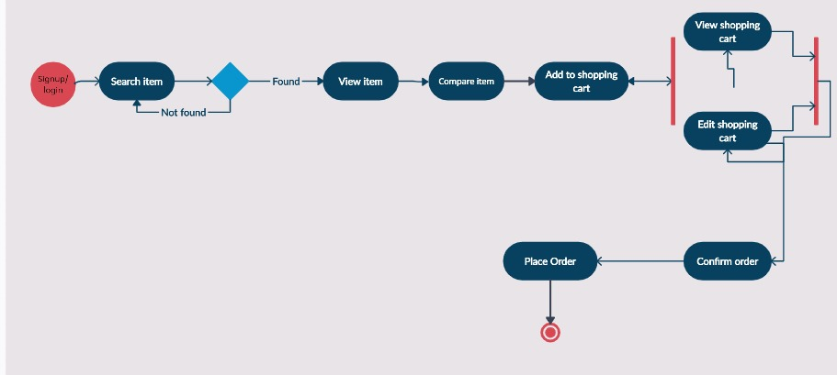

# III. Proposed methodology block diagram

**IV. Limitations Overcome by DealHunter Application**

In reviewing the landscape of price comparison apps, it becomes evident that there are several areas where further enhancements can be made to create a competitive and user-friendly platform. The following suggestions are presented to address some of the common limitations found in existing apps and to guide the development of the 'DealHunter' app:

## Real-time Price Updates:

An essential feature for modern price comparison apps is real-time price updates. To ensure users receive the most accurate and up-to-date data, it is crucial that 'DealHunter' implement a system that continuously monitors and updates prices and stock information from various retailers. This not only enhances user trust but also allows for better decision-making.

## Deals and Alerts:

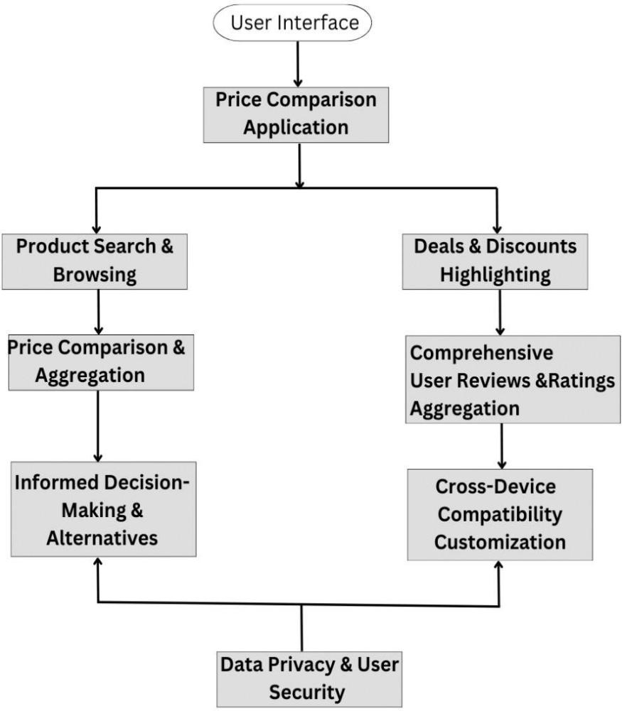One of the primary features that sets 'DealHunter' apart from traditional price comparison apps is its comprehensive

approach to finding deals and providing real-time alerts to users. Users of the app can not only search for the best prices but can also set up personalized deal alerts. By inputting their preferences and desired products, users can receive notifications whenever a deal matching their criteria becomes available. This feature ensures that users never miss out on an opportunity to save money. 'DealHunter' offers a robust and dynamic system for deals and alerts, allowing users to tailor their preferences to a high degree of specificity, from price thresholds to product categories.

## Guided Paths:

To enhance the user experience and simplify the search for the best deals, 'DealHunter' has introduced guided paths. These are user-friendly, step-by-step processes designed to assist users in finding the exact products or deals they're looking for. Guided paths cover a wide range of scenarios, from searching for electronics to planning a vacation. The app offers a selection of predefined paths with optimized filters and search parameters, making it easier for users to navigate through a sea of choices and discover their desired products or deals with minimal effort. This feature is particularly helpful for users who may be unsure about how to effectively search for specific items.

## All-Category Products:

'DealHunter' aims to be a one-stop destination for shoppers of all preferences. In line with this objective, the app provides access to products across a wide array of categories. Whether users are in search of the latest tech gadgets, fashion apparel, home appliances, or travel packages, the app offers an extensive selection to cater to diverse needs and interests. This inclusivity allows users to explore and compare prices for products in any category, making 'DealHunter' a versatile tool that can accommodate virtually any shopping requirement.

## Notifications:

Real-time notifications are at the heart of 'DealHunter.' The app ensures that users stay informed about price drops, special promotions, and personalized deals through timely and relevant notifications. These notifications are tailored to the user's preferences and can be fine-tuned according to their frequency and urgency. Users receive alerts for their deal alerts, price tracking, and items they've expressed interest in, enabling them to act quickly when a great deal becomes available. By providing this feature, 'DealHunter' minimizes the need for users to continuously monitor the app and helps them make informed buying decisions.

## User-Friendly Interface:

A clean and intuitive user interface is paramount to the success of any price comparison app. 'DealHunter' should invest in designing a user interface that offers ease of navigation, effective search functionality, and filter options. These improvements will empower users to quickly locate the best deals and streamline their shopping experience.

## User Reviews and Ratings:

Implementing a robust user review and rating system within 'DealHunter' is vital. This feature allows users to access valuable insights and feedback from the community, helping them make informed purchasing decisions. 'DealHunter' should prioritize the authenticity and credibility of these user- generated reviews and ratings

## Data Privacy:

Addressing potential privacy concerns is a critical aspect of app development. 'DealHunter' should establish stringent data protection and privacy policies, ensuring that users' personal information is handled with the utmost care and security. Providing transparency in data usage and options for user data control can help build trust and make users feel secure when using the app.

By focusing on these suggestions and enhancements, 'DealHunter' has the potential to not only overcome the limitations of existing price comparison apps but also create a superior user experience, thereby attracting a broader user base and establishing itself as a leading platform in the field of price comparison apps.

# V. Implementation Result

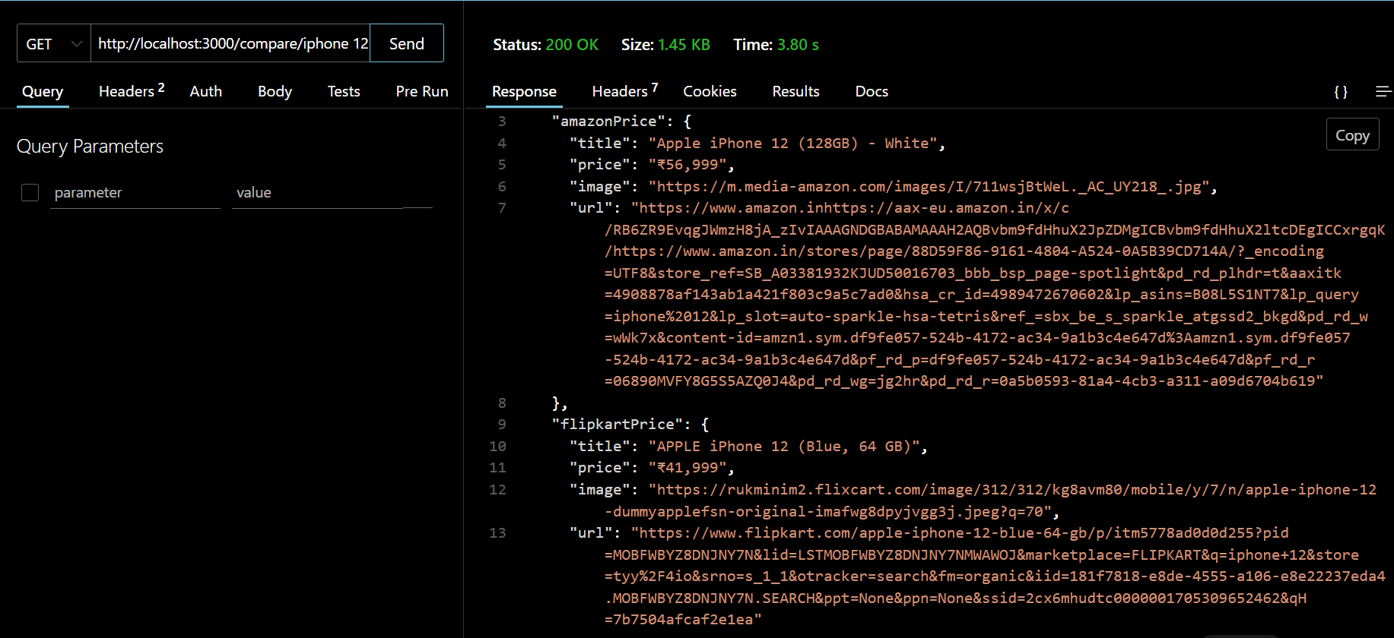

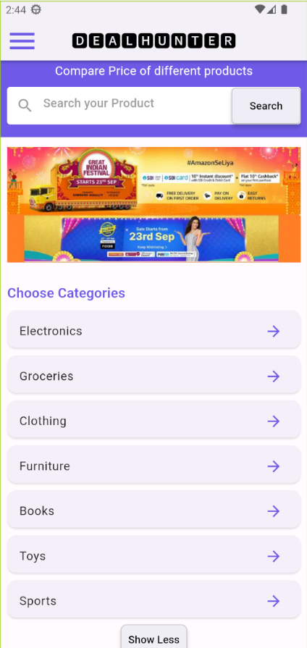 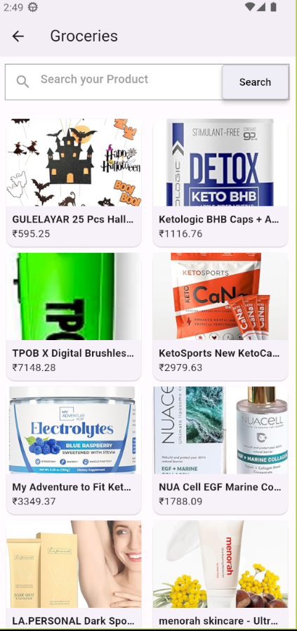

 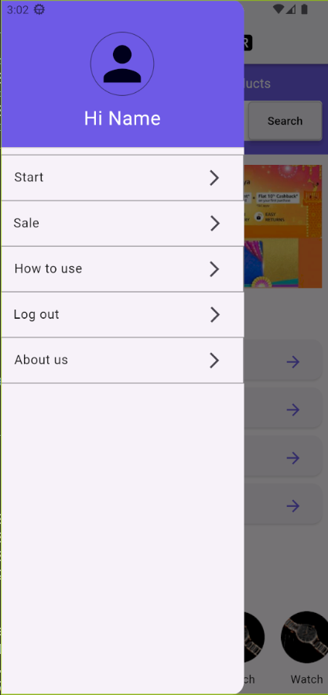

# Conclusion

In conclusion, "DealHunter" represents a significant advancement in the realm of price comparison apps, addressing common limitations and introducing a user-centric approach to enhance the shopping experience. The app's commitment to providing real-time price updates and stock information ensures that users are equipped with accurate and up-to-date data, thus fostering trust and giving them a competitive edge in identifying the best deals. What sets "DealHunter" apart is its dedication to user- friendliness, with a simple and intuitive interface that offers effective search and filter options, making the shopping process straightforward and enjoyable for users of varying tech-savviness. Additionally, the app's transparent ranking system instills confidence by clearly communicating how deals are sorted, promoting transparency in the algorithm. While "DealHunter" may have regional beginnings, its aspirations for global expansion indicate its ambition to become a major player on the international stage. Collaborations with a wide spectrum of retailers, encompassing both large corporations and smaller independent businesses, ensure that the app boasts a diverse selection of products, transforming it into a one-stop destination for shoppers with varying needs. The app recognizes the value of user- generated content by featuring a robust review and rating system, providing users with insights from the community, enabling well-informed purchasing decisions. Complementing its user-focused approach, stringent data protection and privacy policies are in place, addressing growing concerns related to privacy, reassuring users that their personal information is handled securely. In essence, "DealHunter" offers a comprehensive and

user-friendly platform, catering to the diverse needs and preferences of modern consumers, promising a smarter, more efficient, and more enjoyable shopping future. With its unique features and commitment to transparency, data security, and global outreach, the app is poised to lead the way in reshaping the online shopping experience into one that is more satisfying and efficient for users across the globe. In a digital marketplace that is continually evolving, where consumers increasingly rely on platforms like "DealHunter" to discover the best deals and make informed purchasing decisions, this app holds the potential to redefine the future of online shopping, offering a superior experience for users worldwide.

# Reference

1. Julian, LR, and Natalia, F. (2015). "The Use of Web Scraping in Computer Parts and Assembly Price Comparison." In 2015 3rd International Conference on…, IEEE Xplore.
2. Saurkar, AV, Pathare, KG, and Gode, SA. (2018). "An Overview on Web Scraping Techniques and Tools." International Journal on Future…, ijfrcsce.org.
3. Chandrika, GN, Ramasubbareddy, S, and Govinda, K. (2020). "Web Scraping for Unstructured Data over the Web." Embedded Systems and…, Springer.
4. Swami, S., Vidap, P. (2013). "Web Scraping Framework Based on Combining Tag and Value Similarity." Proceedings of the IJCSI International Journal of Computer Science Issues, Vol. 10, Issue

Nath, R., Chopra, K. (2013). "Web Crawlers: Taxonomy, Issues & Challenges." Proceedings of the International Journal of Advanced Research in Computer Science and Software Engineering, Volume 3, Issue 4.

1. Fernández-Villamor, J. I., Blasco-García, J., Iglesias, C. A., Garijo, M. (Year unavailable). "A Semantic Scraping Model for Web Resources" Spain.
2. Lomotey, R. K., Deters, R. (2013). "RSenter: Tool for Topics and Terms Extraction from Unstructured Data Debris." Proceedings of the IEEE International Congress on Big Data.
3. Ambre, A., Gaikwad, P., Pawar, K., Patil, V. (2019). "Web and Android Application for Comparison of E-commerce Products." Academia.edu.
4. Dhawani, R., Shukla, M., Puvar, P., Prajapati, B. (2015). "A Novel Approach to Web Scraping Technology." Proceedings of the International Journal of Advanced Research in Computer Science and Software Engineering, Volume 5, Issue 5.
5. Saeed, S., Naqvi, M., Memon, M. (2020). "E-Commerce Web-Crawling to Facilitate Consumers for Economical Choices." International
6. Journal of…, journal.scientiaca.org